**JOBSHEET 10**

**Queue**



**Name**

Sherly Lutfi Azkiah Sulistyawati

**NIM**

2341720241

**Class**

1I

**Major**

Information Technology

**Study Program**

D4 Informatics Engineering

**Practicum 1**

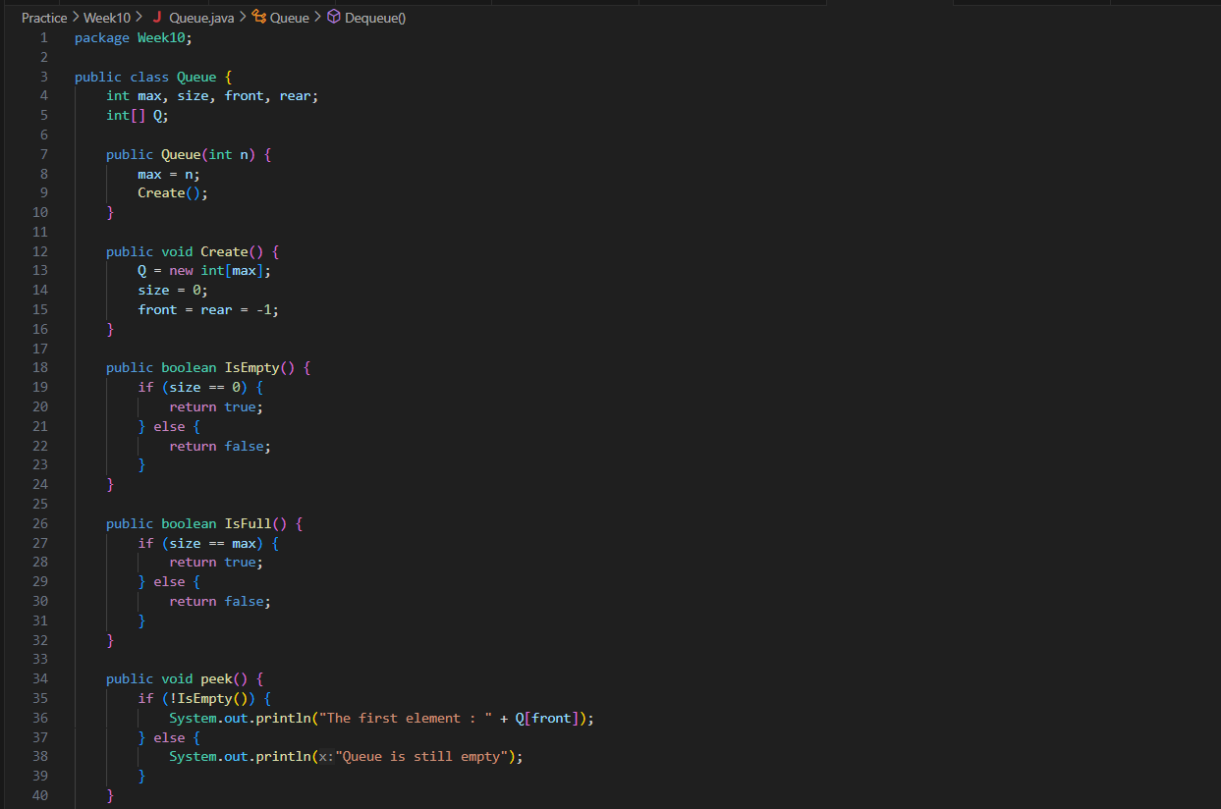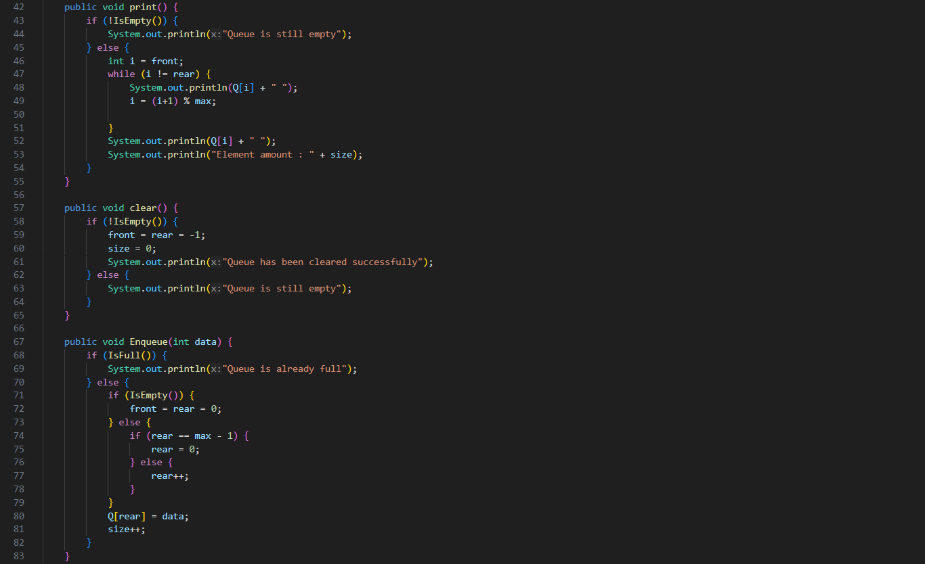

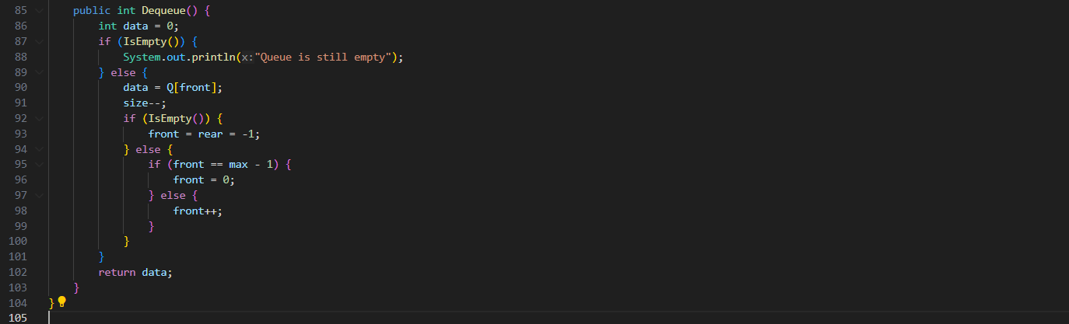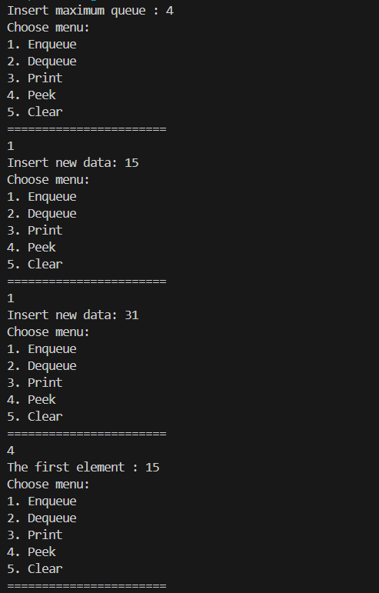

**Question**

1. In method create(), why is the front and rear attribute has initial value with 1 and not 0?
2. In method enqueue(), please explain the usage of this following code

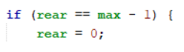

1. Observe enqueue() method, which line of code indicates that the new data will be stored in last position of the queue?
2. Observe dequeue() method, which line of code indicates that the data is removed in the first position of the queue?
3. In dequeue method(), explain the usage of these codes !



1. In method print(), why the loop process has **int i = 0** instead of **int i=front**?
2. In method print(), please explain why we insert this code in our program?



**Practicum 2**

**Question**

1. In class BookMain, when calling **push** method, the argument is **bk.** What information is included in the **bk** variable?

* The argument bk is an instance of the Book class. It includes information about a specific book, such as its title, author name, published year, pages amount, and price.

1. Which of the program that its usage is to define the capacity of the stack?

* The program that defines the capacity of the stack is BookStack. In its constructor BookStack(int size), the size parameter determines the capacity of the stack.

1. What is the function of do-while that is exist in **BookMain** class?

* The do-while loop in the BookMain class is used to repeatedly prompt the user to input information about a book and add it to the stack until the user chooses not to add more data (choose != 'y').

1. Modify the program in **BookMain,** so that the user may choose which operation (push, pop, peek, print) to do in stack from program menu!

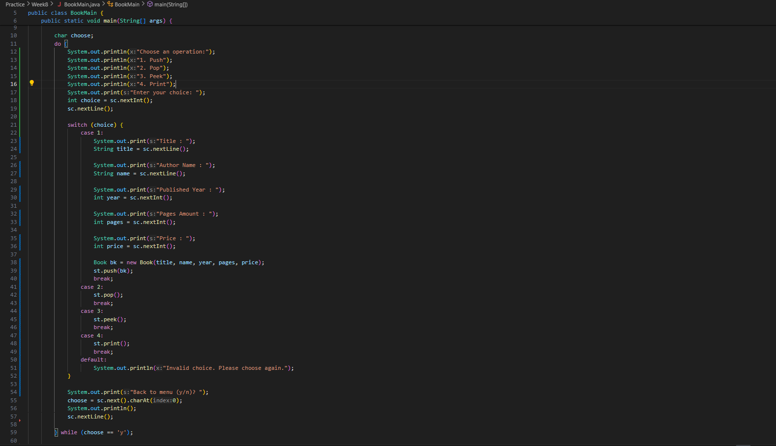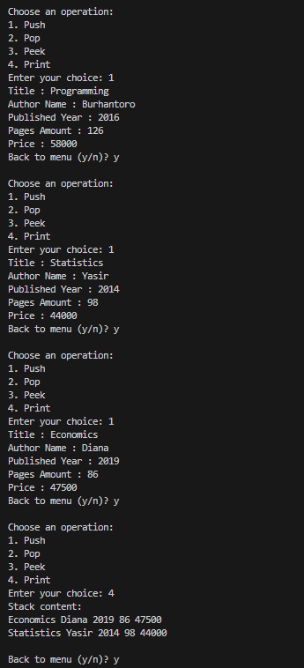 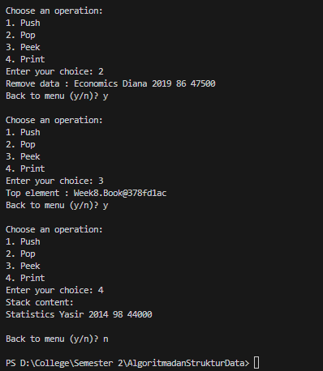

**Practicum 3**

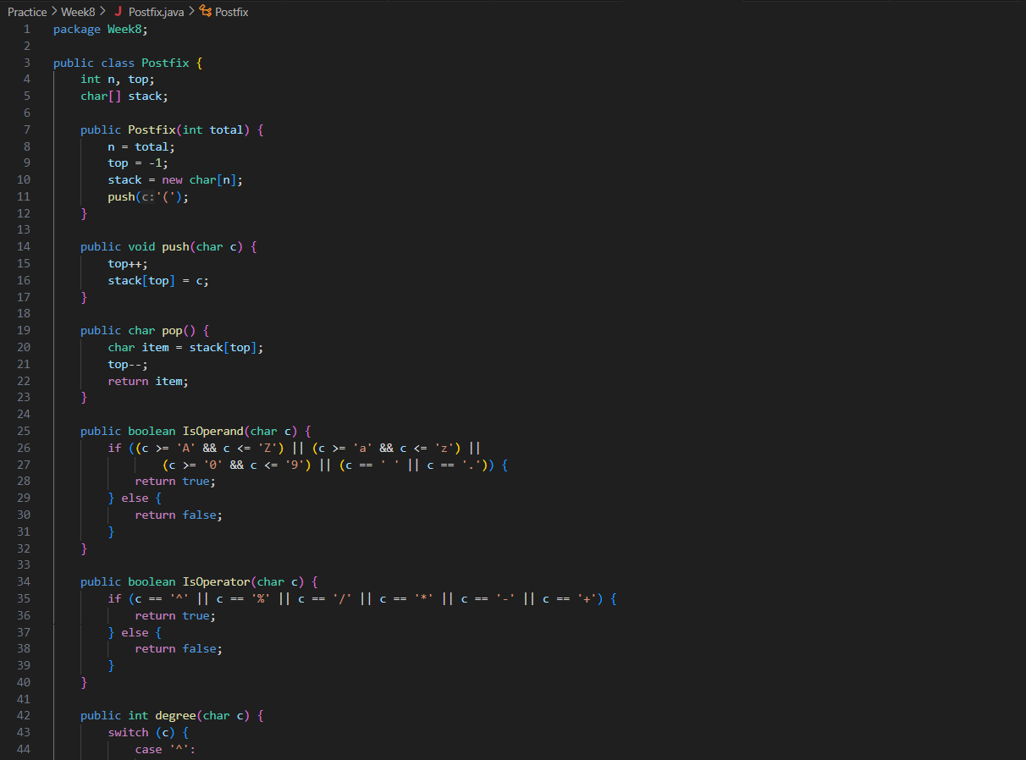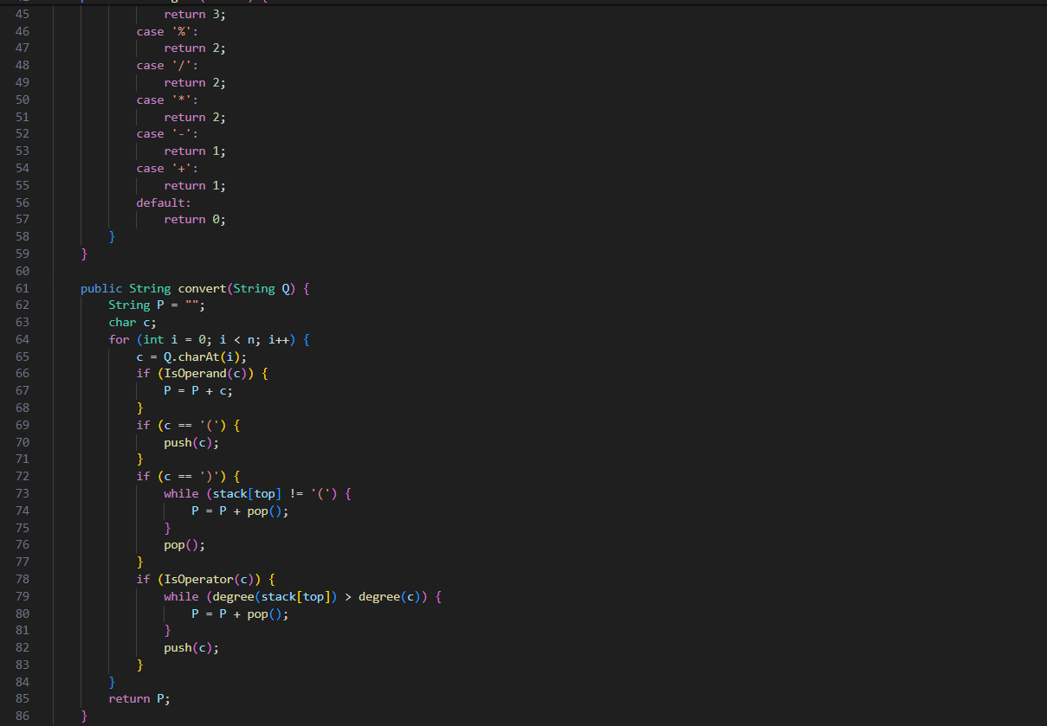

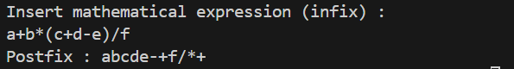

**Question**

1. Please explain the flow of method in **Postfix** class

* The constructor Postfix(int total) initializes the stack with a specified size and pushes an opening parenthesis onto the stack.
* The push(char c) method pushes a character onto the stack.
* The pop() method pops a character from the stack.
* The IsOperand(char c) method checks if a character is an operand (a letter, digit, space, or period).
* The IsOperator(char c) method checks if a character is an operator (+, -, *, /, %, ^).
* The degree(char c) method assigns a precedence level to each operator.
* The convert(String Q) method takes an infix expression Q, iterates through each character, and converts it to a postfix expression P using the stack.

1. What is the function of this program code?



* The code is assigned the character at the i-th position of the string Q. This line reads the character at the current position in the infix expression.

1. Execute the program again, how’s the result if we insert **3*5^(8-6)%3** for the expression?

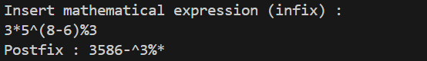

1. In 2nd number, why the braces are not displayed in conversion result? Please explain!

* Braces are not displayed in the conversion result because postfix notation doesn't require explicit grouping; the algorithm handles operator precedence implicitly.

**Assignment**

1. Create a program with Stack implementation to insert a sentence and display the reversed version of the sentence as a result!

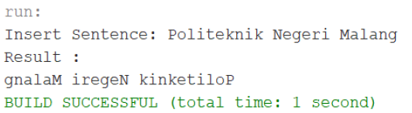

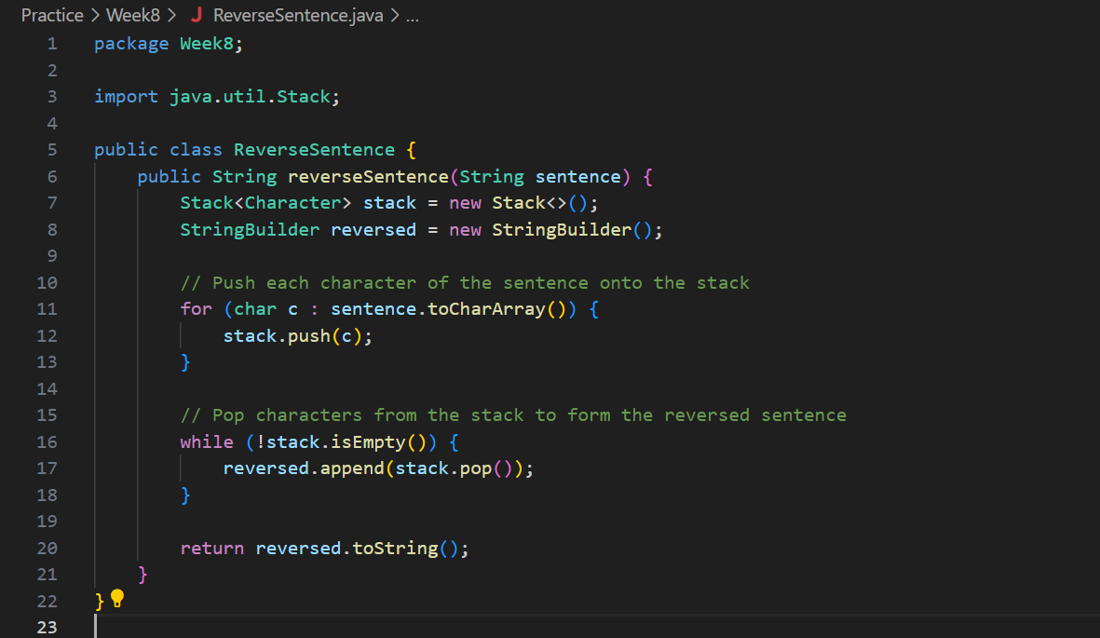 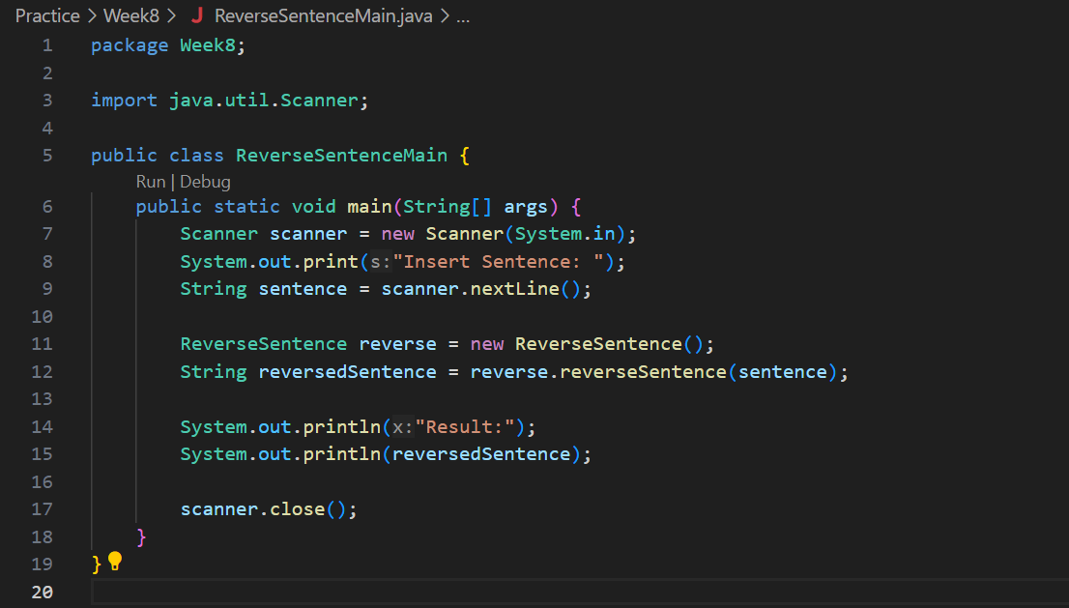

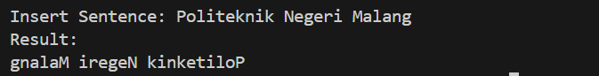

1. Every Sunday, Dewi shops to a supermarket that is in her residential area. Everytime she finishes, she keeps the receipt of what she has bought in a wardrobe. After 2 months, She had 8 receipts. She plans to trade her 5 receipts in exchange for a voucher. Create a program using stack implementation to store Dewi’s receipt. As well as the retrieving the receipts. The information that are included in a receipt are as follows:

* Transaction ID
* Date
* Quantity of items
* Total price